**MY SQL TASK 2**

**Design DB model for Guvi Zen class:**

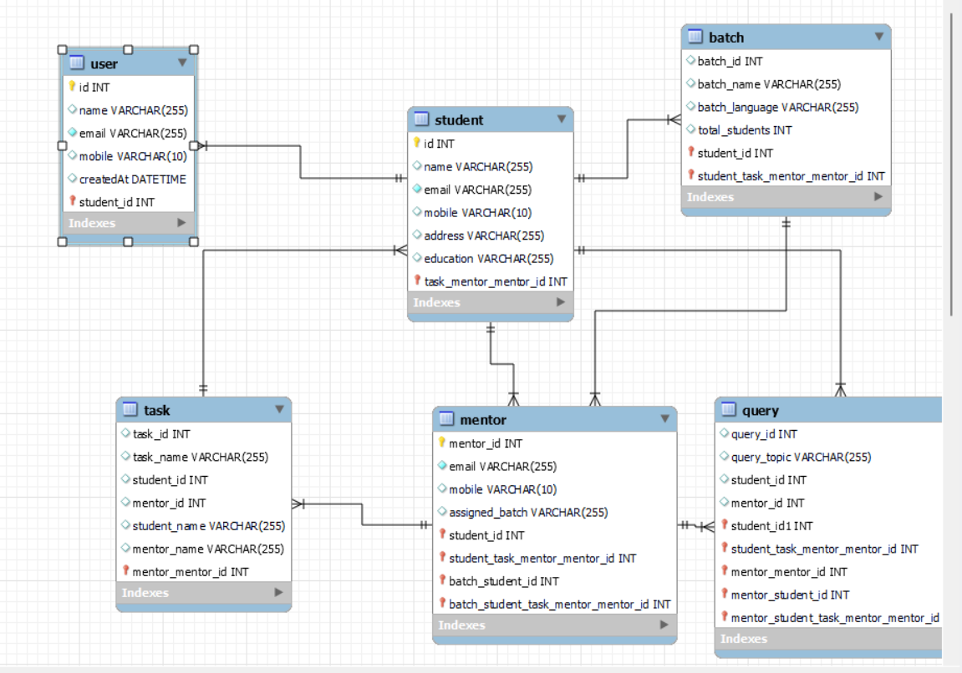

**-- MySQL Workbench Forward Engineering**

SET @OLD_UNIQUE_CHECKS=@@UNIQUE_CHECKS, UNIQUE_CHECKS=0;

SET @OLD_FOREIGN_KEY_CHECKS=@@FOREIGN_KEY_CHECKS, FOREIGN_KEY_CHECKS=0;

SET @OLD_SQL_MODE=@@SQL_MODE, SQL_MODE='ONLY_FULL_GROUP_BY,STRICT_TRANS_TABLES,NO_ZERO_IN_DATE,NO_ZERO_DATE,ERROR_FOR_DIVISION_BY_ZERO,NO_ENGINE_SUBSTITUTION';

-- -----------------------------------------------------

-- Schema mydb

-- -----------------------------------------------------

-- -----------------------------------------------------

-- Schema mydb

-- -----------------------------------------------------

CREATE SCHEMA IF NOT EXISTS `mydb` DEFAULT CHARACTER SET utf8 ;

-- -----------------------------------------------------

-- Schema zen

-- -----------------------------------------------------

-- -----------------------------------------------------

-- Schema zen

-- -----------------------------------------------------

CREATE SCHEMA IF NOT EXISTS `zen` DEFAULT CHARACTER SET utf8mb4 COLLATE utf8mb4_0900_ai_ci ;

USE `mydb` ;

-- -----------------------------------------------------

-- Table `mydb`.`query`

-- -----------------------------------------------------

CREATE TABLE IF NOT EXISTS `mydb`.`query` (

`query_id` INT NOT NULL,

`query_text` VARCHAR(255) NULL,

`student_id` INT NOT NULL,

`mentor_id` INT NOT NULL,

PRIMARY KEY (`query_id`, `student_id`, `mentor_id`),

UNIQUE INDEX `query_id_UNIQUE` (`query_id` ASC) VISIBLE,

UNIQUE INDEX `student_id_UNIQUE` (`student_id` ASC) VISIBLE,

UNIQUE INDEX `mentor_id_UNIQUE` (`mentor_id` ASC) VISIBLE)

ENGINE = InnoDB;

USE `zen` ;

-- -----------------------------------------------------

-- Table `zen`.`mentor`

-- -----------------------------------------------------

CREATE TABLE IF NOT EXISTS `zen`.`mentor` (

`mentor_id` INT NOT NULL,

`email` VARCHAR(255) NOT NULL,

`mobile` VARCHAR(10) NULL DEFAULT NULL,

`assigned_batch` VARCHAR(255) NULL DEFAULT NULL,

`student_id` INT NOT NULL,

`student_task_mentor_mentor_id` INT NOT NULL,

`batch_student_id` INT NOT NULL,

`batch_student_task_mentor_mentor_id` INT NOT NULL,

UNIQUE INDEX `email` (`email` ASC) VISIBLE,

PRIMARY KEY (`mentor_id`, `student_id`, `student_task_mentor_mentor_id`, `batch_student_id`, `batch_student_task_mentor_mentor_id`),

INDEX `fk_mentor_student1_idx` (`student_id` ASC, `student_task_mentor_mentor_id` ASC) VISIBLE,

INDEX `fk_mentor_batch1_idx` (`batch_student_id` ASC, `batch_student_task_mentor_mentor_id` ASC) VISIBLE,

CONSTRAINT `fk_mentor_student1`

FOREIGN KEY (`student_id` , `student_task_mentor_mentor_id`)

REFERENCES `zen`.`student` (`id` , `task_mentor_mentor_id`)

ON DELETE NO ACTION

ON UPDATE NO ACTION,

CONSTRAINT `fk_mentor_batch1`

FOREIGN KEY (`batch_student_id` , `batch_student_task_mentor_mentor_id`)

REFERENCES `zen`.`batch` (`student_id` , `student_task_mentor_mentor_id`)

ON DELETE NO ACTION

ON UPDATE NO ACTION)

ENGINE = InnoDB

DEFAULT CHARACTER SET = utf8mb4

COLLATE = utf8mb4_0900_ai_ci;

-- -----------------------------------------------------

-- Table `zen`.`task`

-- -----------------------------------------------------

CREATE TABLE IF NOT EXISTS `zen`.`task` (

`task_id` INT NULL DEFAULT NULL,

`task_name` VARCHAR(255) NULL DEFAULT NULL,

`student_id` INT NULL DEFAULT NULL,

`mentor_id` INT NULL DEFAULT NULL,

`student_name` VARCHAR(255) NULL DEFAULT NULL,

`mentor_name` VARCHAR(255) NULL DEFAULT NULL,

`mentor_mentor_id` INT NOT NULL,

PRIMARY KEY (`mentor_mentor_id`),

CONSTRAINT `fk_task_mentor1`

FOREIGN KEY (`mentor_mentor_id`)

REFERENCES `zen`.`mentor` (`mentor_id`)

ON DELETE NO ACTION

ON UPDATE NO ACTION)

ENGINE = InnoDB

DEFAULT CHARACTER SET = utf8mb4

COLLATE = utf8mb4_0900_ai_ci;

-- -----------------------------------------------------

-- Table `zen`.`student`

-- -----------------------------------------------------

CREATE TABLE IF NOT EXISTS `zen`.`student` (

`id` INT NOT NULL,

`name` VARCHAR(255) NULL DEFAULT NULL,

`email` VARCHAR(255) NOT NULL,

`mobile` VARCHAR(10) NULL DEFAULT NULL,

`address` VARCHAR(255) NULL DEFAULT NULL,

`education` VARCHAR(255) NULL DEFAULT NULL,

`task_mentor_mentor_id` INT NOT NULL,

PRIMARY KEY (`id`, `task_mentor_mentor_id`),

UNIQUE INDEX `email` (`email` ASC) VISIBLE,

INDEX `fk_student_task1_idx` (`task_mentor_mentor_id` ASC) VISIBLE,

CONSTRAINT `fk_student_task1`

FOREIGN KEY (`task_mentor_mentor_id`)

REFERENCES `zen`.`task` (`mentor_mentor_id`)

ON DELETE NO ACTION

ON UPDATE NO ACTION)

ENGINE = InnoDB

DEFAULT CHARACTER SET = utf8mb4

COLLATE = utf8mb4_0900_ai_ci;

-- -----------------------------------------------------

-- Table `zen`.`batch`

-- -----------------------------------------------------

CREATE TABLE IF NOT EXISTS `zen`.`batch` (

`batch_id` INT NULL DEFAULT NULL,

`batch_name` VARCHAR(255) NULL DEFAULT NULL,

`batch_language` VARCHAR(255) NULL DEFAULT NULL,

`total_students` INT NULL DEFAULT NULL,

`student_id` INT NOT NULL,

`student_task_mentor_mentor_id` INT NOT NULL,

PRIMARY KEY (`student_id`, `student_task_mentor_mentor_id`),

CONSTRAINT `fk_batch_student1`

FOREIGN KEY (`student_id` , `student_task_mentor_mentor_id`)

REFERENCES `zen`.`student` (`id` , `task_mentor_mentor_id`)

ON DELETE NO ACTION

ON UPDATE NO ACTION)

ENGINE = InnoDB

DEFAULT CHARACTER SET = utf8mb4

COLLATE = utf8mb4_0900_ai_ci;

-- -----------------------------------------------------

-- Table `zen`.`query`

-- -----------------------------------------------------

CREATE TABLE IF NOT EXISTS `zen`.`query` (

`query_id` INT NULL DEFAULT NULL,

`query_topic` VARCHAR(255) NULL DEFAULT NULL,

`student_id` INT NULL DEFAULT NULL,

`mentor_id` INT NULL DEFAULT NULL,

`student_id1` INT NOT NULL,

`student_task_mentor_mentor_id` INT NOT NULL,

`mentor_mentor_id` INT NOT NULL,

`mentor_student_id` INT NOT NULL,

`mentor_student_task_mentor_mentor_id` INT NOT NULL,

PRIMARY KEY (`student_id1`, `student_task_mentor_mentor_id`, `mentor_mentor_id`, `mentor_student_id`, `mentor_student_task_mentor_mentor_id`),

INDEX `fk_query_mentor1_idx` (`mentor_mentor_id` ASC, `mentor_student_id` ASC, `mentor_student_task_mentor_mentor_id` ASC) VISIBLE,

CONSTRAINT `fk_query_student1`

FOREIGN KEY (`student_id1` , `student_task_mentor_mentor_id`)

REFERENCES `zen`.`student` (`id` , `task_mentor_mentor_id`)

ON DELETE NO ACTION

ON UPDATE NO ACTION,

CONSTRAINT `fk_query_mentor1`

FOREIGN KEY (`mentor_mentor_id` , `mentor_student_id` , `mentor_student_task_mentor_mentor_id`)

REFERENCES `zen`.`mentor` (`mentor_id` , `student_id` , `student_task_mentor_mentor_id`)

ON DELETE NO ACTION

ON UPDATE NO ACTION)

ENGINE = InnoDB

DEFAULT CHARACTER SET = utf8mb4

COLLATE = utf8mb4_0900_ai_ci;

-- -----------------------------------------------------

-- Table `zen`.`user`

-- -----------------------------------------------------

CREATE TABLE IF NOT EXISTS `zen`.`user` (

`id` INT NOT NULL,

`name` VARCHAR(255) NULL DEFAULT NULL,

`email` VARCHAR(255) NOT NULL,

`mobile` VARCHAR(10) NULL DEFAULT NULL,

`createdAt` DATETIME NULL DEFAULT CURRENT_TIMESTAMP,

`student_id` INT NOT NULL,

PRIMARY KEY (`id`, `student_id`),

UNIQUE INDEX `email` (`email` ASC) VISIBLE,

INDEX `fk_user_student_idx` (`student_id` ASC) VISIBLE,

CONSTRAINT `fk_user_student`

FOREIGN KEY (`student_id`)

REFERENCES `zen`.`student` (`id`)

ON DELETE NO ACTION

ON UPDATE NO ACTION)

ENGINE = InnoDB

DEFAULT CHARACTER SET = utf8mb4

COLLATE = utf8mb4_0900_ai_ci;

SET SQL_MODE=@OLD_SQL_MODE;

SET FOREIGN_KEY_CHECKS=@OLD_FOREIGN_KEY_CHECKS;

SET UNIQUE_CHECKS=@OLD_UNIQUE_CHECKS;